PROJECT SUMMARY : PRODUCT INVENTORY MANAGEMENT SYSTEM

Team Details:
* Team Leader: AKSHYAN G
* Team Members: AJAY S, AJITH A, AKASH A
1. PROJECT OVERVIEW
This project is a secure backend system designed for managing a product inventory.
* Key Objectives: Establish a robust backend for tracking and managing products.
* Target Users: Authorized personnel requiring access to the inventory management system.
2. PRE-REQUISITES
* Knowledge Requirements: Fundamental understanding of backend development, RESTful APIs, and database management.
3. PROJECT ARCHITECTURE
The application is built using a high-level architecture diagram illustrating the three-tier backend structure.
TECHNICAL ARCHITECTURE
* Backend Architecture (Node.js + Express): Handles server logic and incoming HTTP requests.
* Database Architecture (MongoDB): Manages data storage for users and products.
4. CORE FEATURES & BACKEND DEVELOPMENT
The system logic is divided into dedicated controllers to manage user authentication and product data efficiently.
Auth Controllers
* Responsibilities: Securely manage user credentials and issue authentication tokens.
* Main Functionalities: User registration and user login operations.
Product Controller
* Responsibilities: Handle the core business logic for inventory data manipulation.
* Main Functionalities: Create, read, update, and delete product entries in the database.
Security & Routing
* Create Middleware: Custom authentication middleware verifies incoming requests.
* Product Routes: Product routes manage all inventory-related operations such as creating, retrieving, updating, and deleting products. These routes are protected using authentication middleware to ensure only authorized users can access their own product data.
* Connect Routes to Server: Finalized endpoints are integrated into the main application.

5. DATABASE CONFIGURATION AND SETUP
Proper setup of the MongoDB database connection.
Database Collections Screenshot
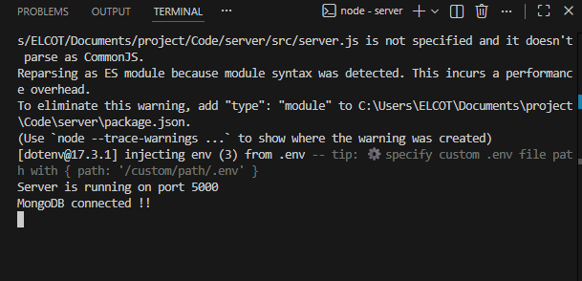
6. EXECUTION STEPS & API TESTING
The server was executed following the execution steps, and endpoints were validated using Thunder Client.
User Registration API Screenshot
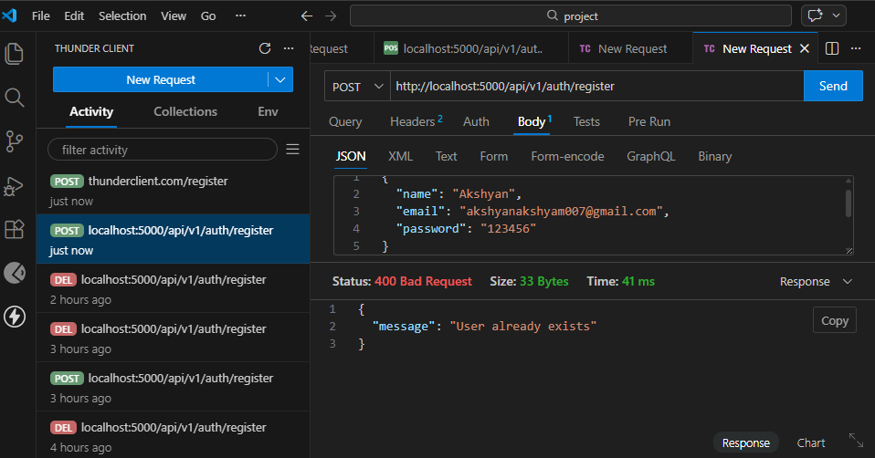
User Login API Screenshot
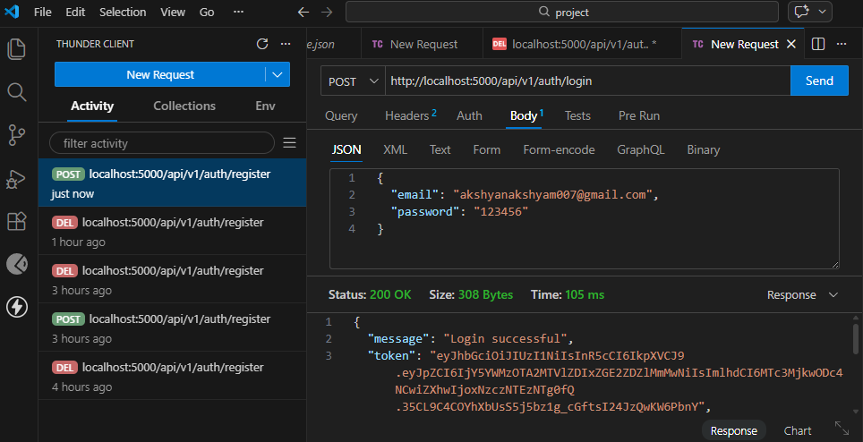
Create Product API Screenshot
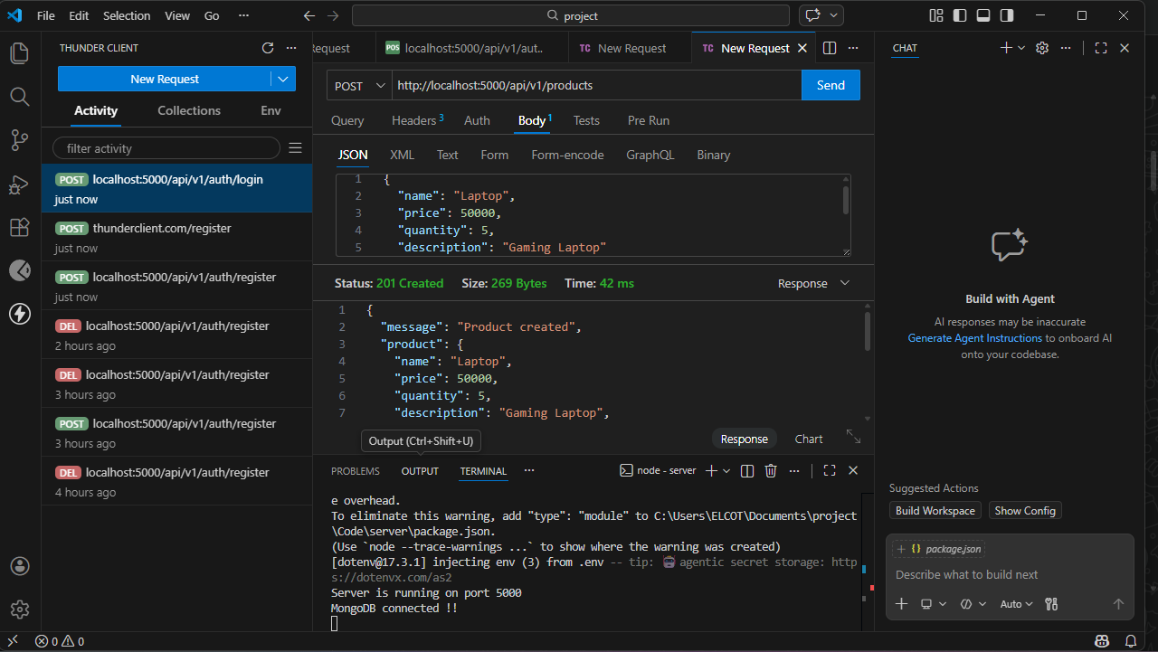
Retrieve Products API Screenshot
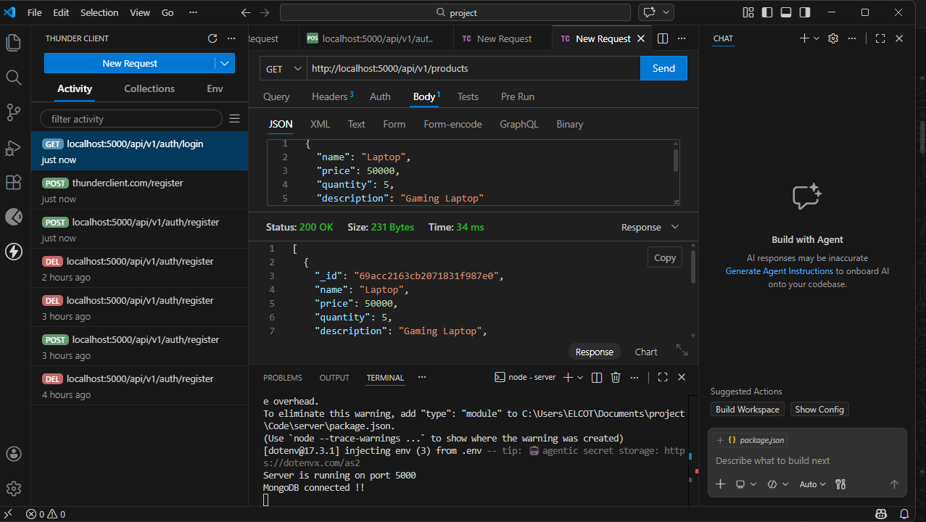
Delete Product API Screenshot
